Walk 13 Monnington Walk
Last walked in May 2019

Description. A 6 km (3.7 mile) easy pleasant walk along small roads, grassy lanes and thru Bulmers apple orchards.
Start. Monnington Village by a red telephone box. Explorer Map OL13 Grid 372435.
Directions from Whitecross roundabout (Turn milometer to zero). Take the A438 to Brecon and at 7.4 miles TL to Monnington-on-Wye. At 8.2 miles TL toward Monnington Court and park on the verge near to the red telephone box.

Monnington Walk is no doubt grateful for being off the beaten track, away from the busy A438, and close by the River Wye. If apple orchards are much in evidence, then discovery that this is part of the Bulmer estates will not be a surprise. Visitors are made to feel welcome rather than an intrusion, and a further bonus is that this walk involves the minimum of ascent - ideal after Sunday lunch!

1. Monnington Court. Walk along the road towards Monnington Court and take the first turning on your R, a bridleway that leads you past Albert House (R) and onto Monnington Walk, a 1km long avenue with a line of fir trees on either side. Monnington Court, a building largely of the seventeenth century, but with a fifteenth-century wing closest to the church. The avenue, lined with fir trees was probably planted in 1628 to mark the election of William Tomkins as MP for nearby Weobley. The firs are interspersed with yews, and some replacement planting has taken place. There are orchards on your L, at there best in mid or late May when in full blossom. Continue to the end of Monnington Walk, initially walking along a tarmac lane and when the lane bends L towards a house you carry straight on thru a metal gate and onto the grassy avenue that has a line of trees either side. At the end of the avenue, after about 1km and just before reaching a metal gate into woods, TR and go thru a gate into F1.

2. Gate. Carry on straight across the field, keeping to the fence/hedge on your R. At the end of the field you go thru a metal gate and TR to continue along an unmettled road/track. Walk along this road/track for almost a kilometer, ignoring any way marked footpaths L or R, the road/track then bends L. A little further on, by a hydrant 76/6, the road/track bends R and transforms into a narrow tarmac road.

3. Monnington House. Continue along this road for about 1.3 km, ignoring the road on your R (where the telephone box is) that goes to Monnington Court. Continue along this road, (which ends at the main A438 road to Hereford), and not far from the main A438 a big oak tree, a footpath sign and a metal gate on the R hand side is reached, at this point you TR and go thru the metal gate into Bulmers orchard fields.

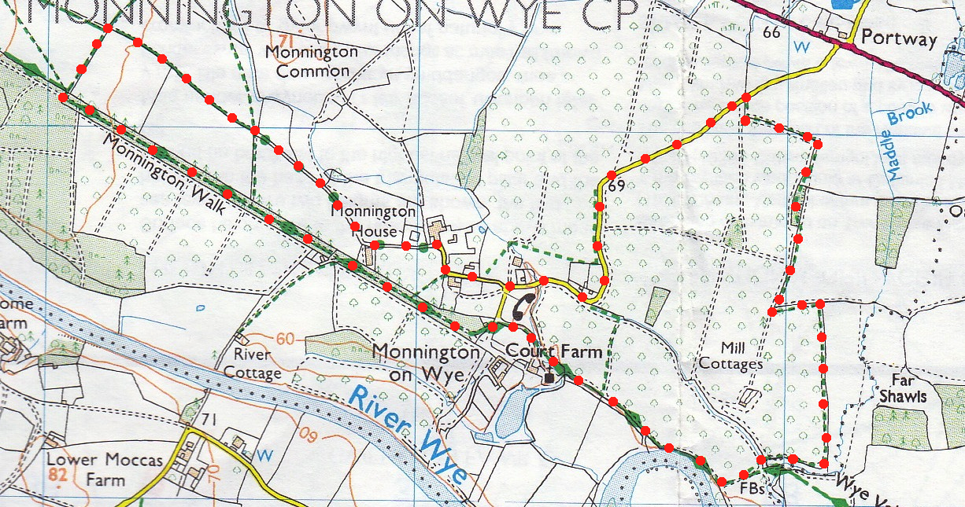
4. Bulmers Orchard Fields. The history of Bulmers began in 1887, when H P (Percy) Bulmer, youngest son of the Rector of Credenhill, first pressed apples from his father's orchard. Bulmers cider can be found worldwide and Strongbow is sold across Europe, Scandinavia, USA, Australasia and the Far East. The company is now owned by Heineken. Walk along the L field edge, (after a few meters the hedge turns L, and further on it turns R). Keep to the hedge on your L and follow the field boundary around for about 1.3 km, till you reach the end of various orchard fields, which is just in front of a brook and a wooded area. Before reaching the field end the hedge turns sharp L, then it bears R and continues on to the end of the field. At the field end you TR and continue along the edge of the field, keeping the brook/wooded area on your L. After a couple of hundred meters you TL and cross over a wooden bridge into another orchard field. Go straight across, going between sets of orchards and heading for the River Wye.

5. River Wye. TR when you get to the river. When the river bends L you follow the fence on you L, the fence heads off R towards the church. Follow the way marks to the church. Uvedale and Mary Tomkins of Monnington Court rebuilt the church in 1679 and there is a carved Royal Stuart Arms of Charles II on the South wall. The 17th Century fittings are virtually all intact and typically almost everything has twisted legs or balustrades including the altar table, chancel screen and two-decker pulpit. The famous ‘Heroes Grave’ of William Williams, who fought under the Duke of Wellington at Waterloo, is in the churchyard. You have a stream on your R as you pass under the church archway that has seats L and R. The path bears L away from the stream to the road, the start point.
1
2
3
4

5

